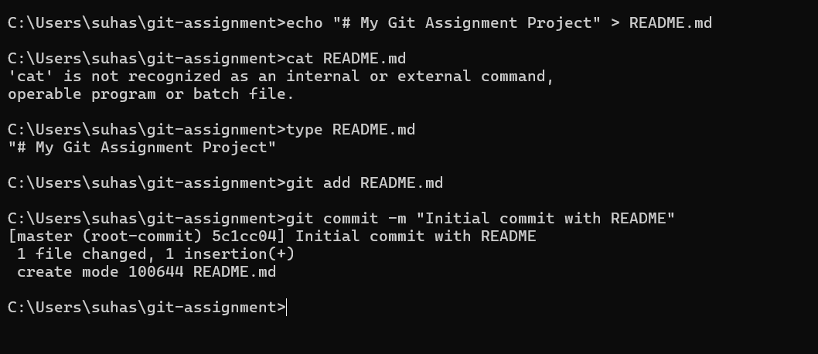
Practice Question Day 1
Screenshot – 1 - Repository Initialization
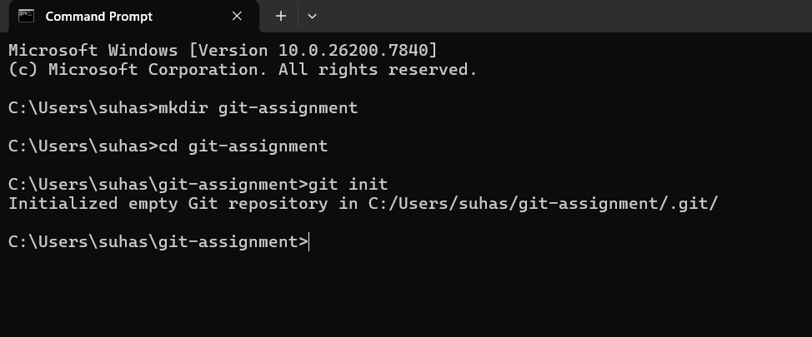
Screenshot – 2 - README File Creation
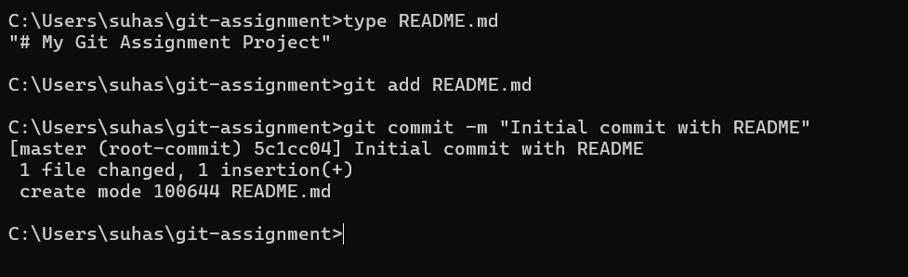
Screenshot – 3 - Initial Commit
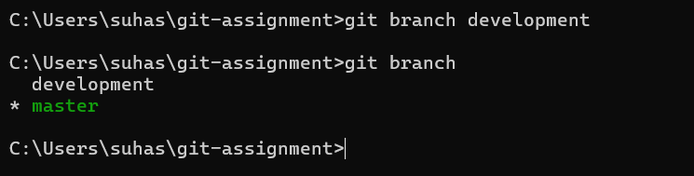
Screenshot – 4 - Branch Creation
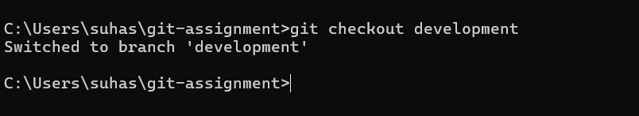
Screenshot – 5 - Switch to Development Branch
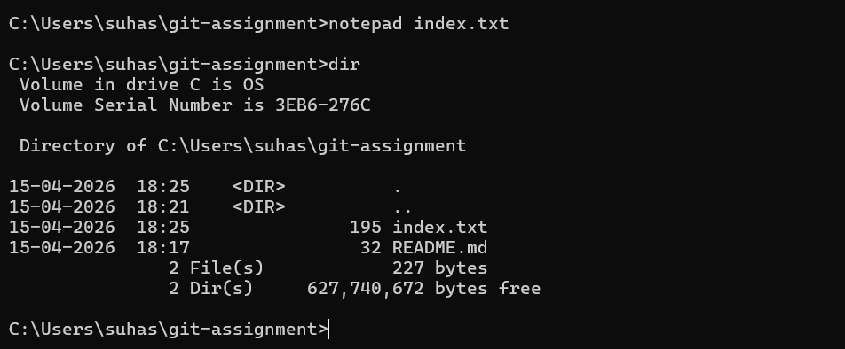
Screenshot – 6 - index.txt File with Java Q&A
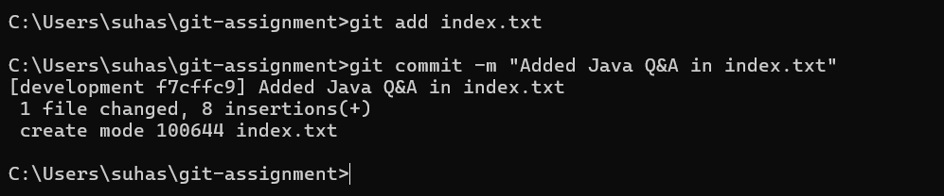
Screenshot – 7 - Commit in Development Branch
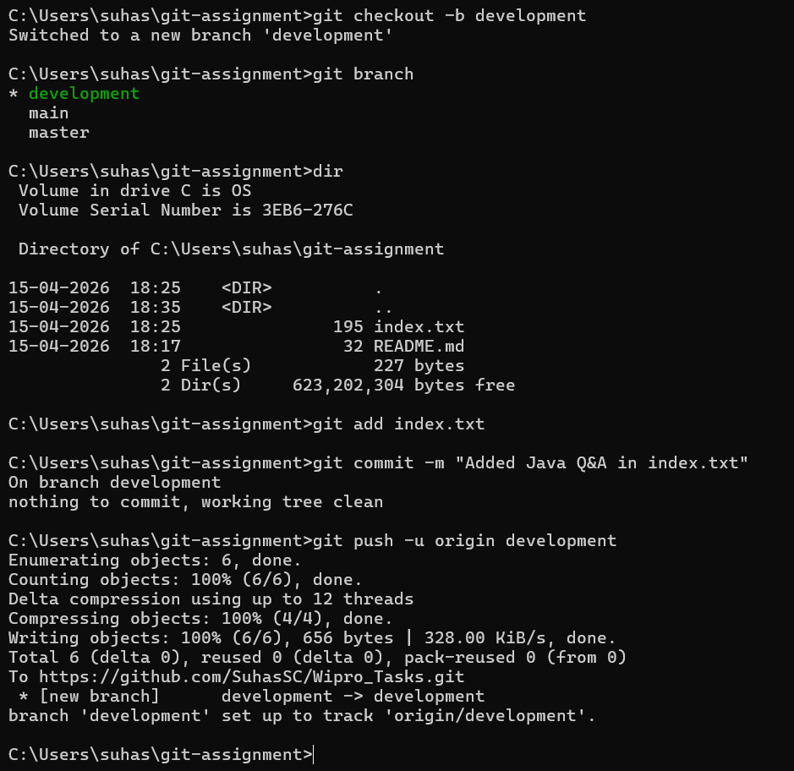
Screenshot – 8 - Push to Remote Repository
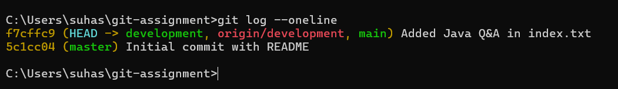
Screenshot – 9 - Git Log

